Individual Project

Nitigya Vasudev

Business Analytics, Conestoga College, Institute of Technology and Advanced Learning

INFO8076: SQL and Data Analysis

Jey Kumaresan

Feb 23, 2025

- Goal of the project – What do you want to learn from this data?

The aim of this project is to explore the Open Database of Healthcare Institutions (ODHF) with the goal of providing an understanding of the variety and spread of healthcare institutions in Canada. The focus is on creating a relational database, learning how to use SQL functions like aliases, subqueries, and CTEs, and developing reusable views for user’s accounts. The project intends to enhance healthcare access and planning policies, improve the gaps in healthcare coverage, improve the knowledge on SQL, and transform the data through integration, cleaning, and querying.

- Data Source and Data Cleaning Process

Data Source: https://www.statcan.gc.ca/en/lode/databases/odhf

Data Cleaning Procedure for the Project
- Duplicate Removal: Using complex matching techniques based on facility name, address, and geographic coordinates, a duplication process was put in place to guarantee that every healthcare institution had a unique record.
- Standardised Column Names: To maintain consistency and conform to the database structure, columns were renamed and formatted consistently.

- Null Value Handling: To ensure data completeness, all null fields were substituted with the proper default values, such as "Unknown" for text fields, "0" for numeric fields, and "N/A" for dates.

- Data Type Conversion: To guarantee correctness and compatibility for SQL operations, columns were transformed into the appropriate data types, such as date, numeric, and text formats.
- Relational schema/ERD

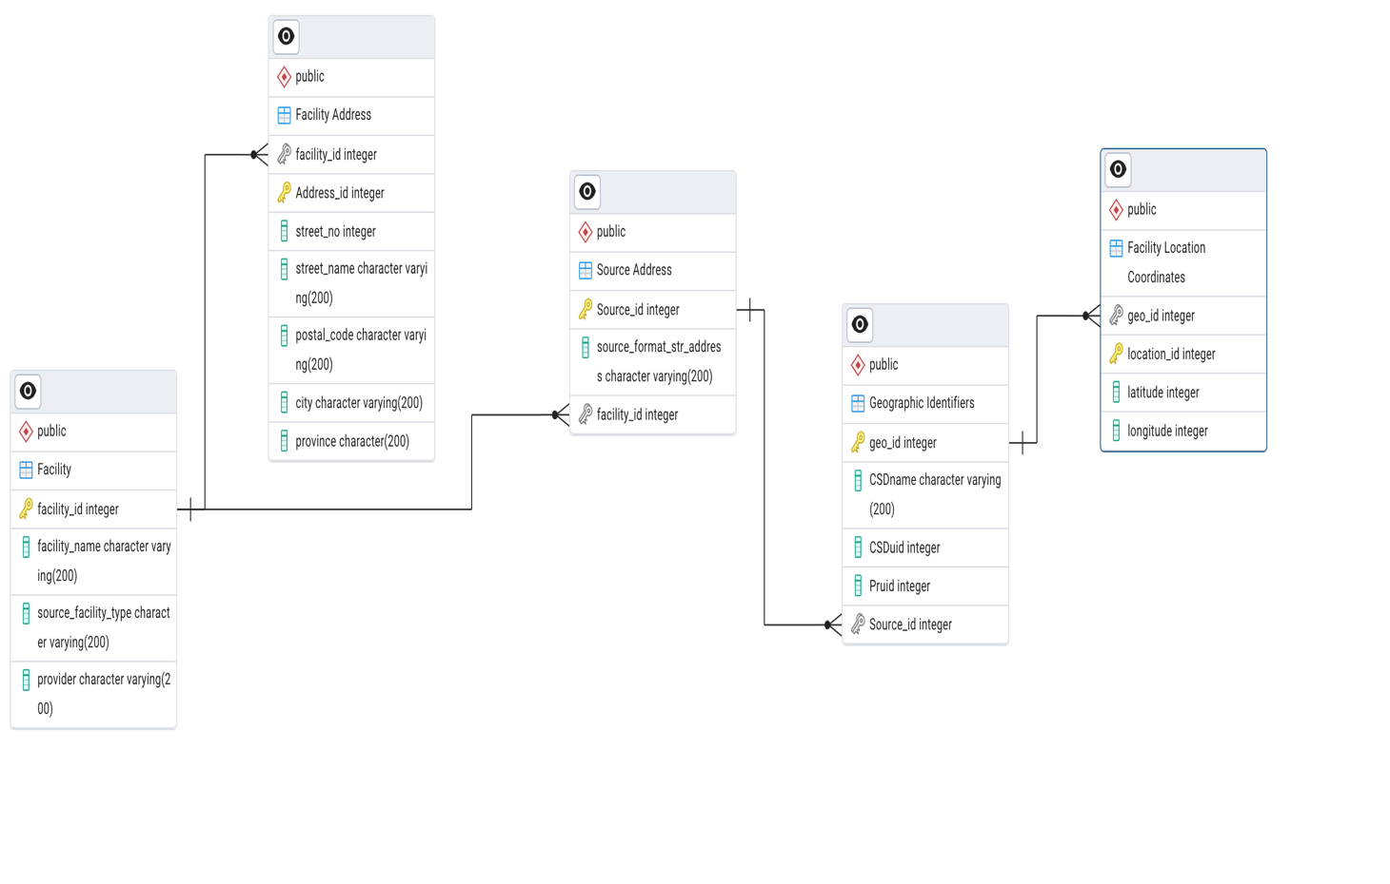

- SQL Queries

Query 1: --Filtering and Sorting

SELECT facility_id, city, postal_code
FROM Facility_Address
WHERE province = 'bc'
ORDER BY city ASC

Output

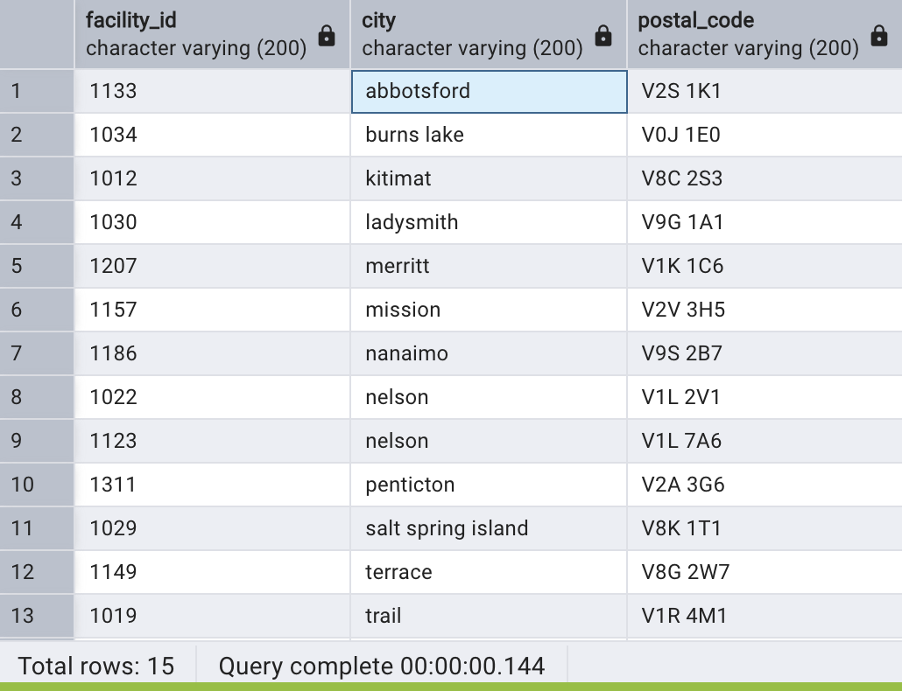
Insight
This query retrieves facility IDs, cities, and postal codes for healthcare facilities situated in British Columbia, sorted by city. Understanding the areas in healthcare helpful for facility expansion planning in underserved areas.

Query 2: -- Counting Facilities in Each City:

SELECT fa.city, COUNT(f.facility_id) AS facility_count
FROM Facility f
INNER JOIN Facility_address fa ON f.facility_id = fa.facility_id
GROUP BY fa.city

Output

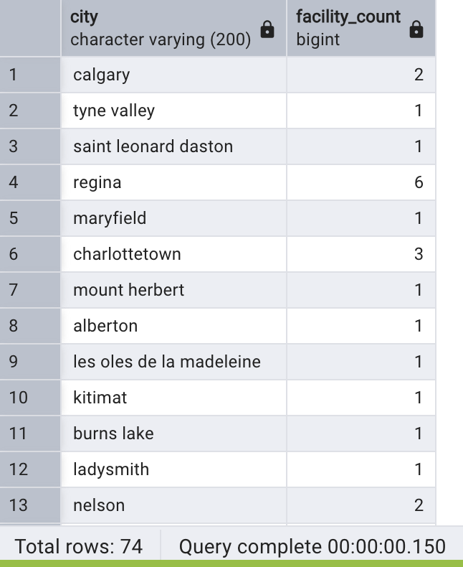
Insight
This query shows the quantity of health facilities in the city and shows whether cities are high or low on facility density. It helps on which resources should be distributed to which areas, assists in revealing areas with poor health access, and gives data for planning new expansion of facilities that will create better access.

Query 3: -- Top 5 Cities with the Most Facilities:

SELECT fa.city, COUNT(fa.city) AS facility_count
FROM Facility_address fa
GROUP BY fa.city
ORDER BY facility_count DESC;

Output

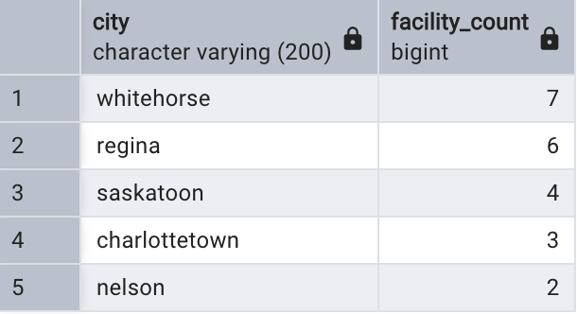
Insight
This search identifies cities with strong healthcare infrastructure by highlighting healthcare hubs with many facilities. It assists in locating regions with greater service coverage and possibly a larger number of people who depend on these services.

Query 4: -- Facilities in a Specific City

SELECT facility_name, provider
FROM Facility
WHERE facility_id IN (
SELECT facility_id
FROM Facility_Address
WHERE city = 'whitehorse'
)
Output

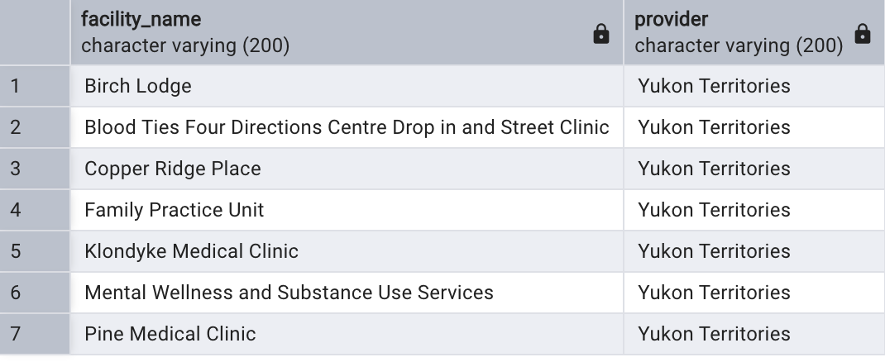
Insight
'Whitehorse' is an example of a city's facilities:
This search provides details about the range and availability of healthcare services in Whitehorse by listing all facilities and their providers. It draws attention to how well the city's healthcare system serves the needs of its people.

Query 5: -- Facilities in Provinces with Fewer than 5 Facilities:

SELECT f.facility_id, f.facility_name, fa.province
FROM Facility f
JOIN Facility_address fa ON f.facility_id = fa.facility_id
WHERE fa.province IN (
SELECT fa.province
FROM Facility_address fa
GROUP BY fa.province
HAVING COUNT(fa.facility_id) < 5
)
Output

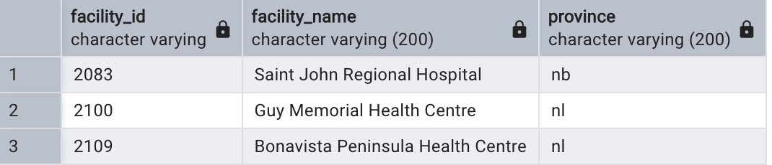
Insight
Provinces with very insufficient healthcare infrastructure are identified by this query. Strategic planning for new facilities or resource allocation may be necessary in these underserved areas to address possible obstacles to healthcare accessibility.

Query 6: --Classify Cities Based on Facility Count Using Subquery and CASE:

SELECT
f.facility_id,
f.facility_name,
f.provider,
fa.city,
fa.province,
CASE
WHEN fa.province = 'ab' THEN 'Alberta'
WHEN fa.province = 'bc' THEN 'British Columbia'
WHEN fa.province = 'qc' THEN 'Quebec'
ELSE 'Other Province'
END AS province_full_name,
(SELECT COUNT(*)
FROM Facility_Address
WHERE city = fa.city) AS facilities_in_city
FROM
Facility f
JOIN
Facility_Address fa ON f.facility_id = fa.facility_id;

Output
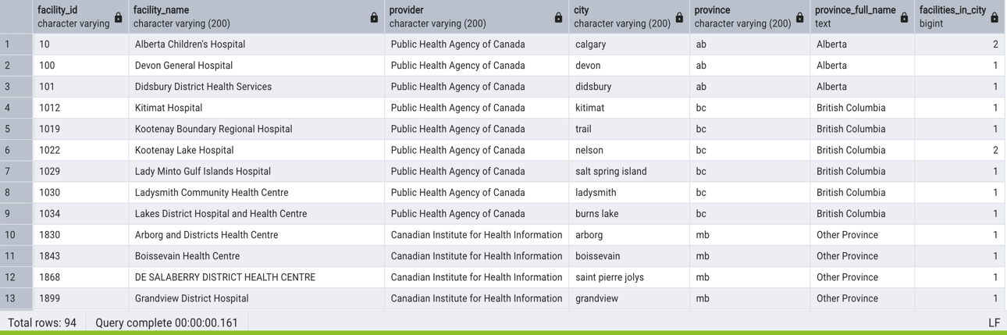
Insight
This query counts the number of facilities in each city and groups them by province. It offers a thorough summary of healthcare density by region, highlighting inequalities and areas that could use improvement.

Query 7: - -- CREATE VIEW

CREATE VIEW SimpleFacilityView AS
SELECT
f.facility_id,
f.facility_name,
fa.city,
fa.province
FROM
Facility f
JOIN
Facility_Address fa
ON
f.facility_id = fa.facility_id;

SELECT * FROM SimpleFacilityView;

Output

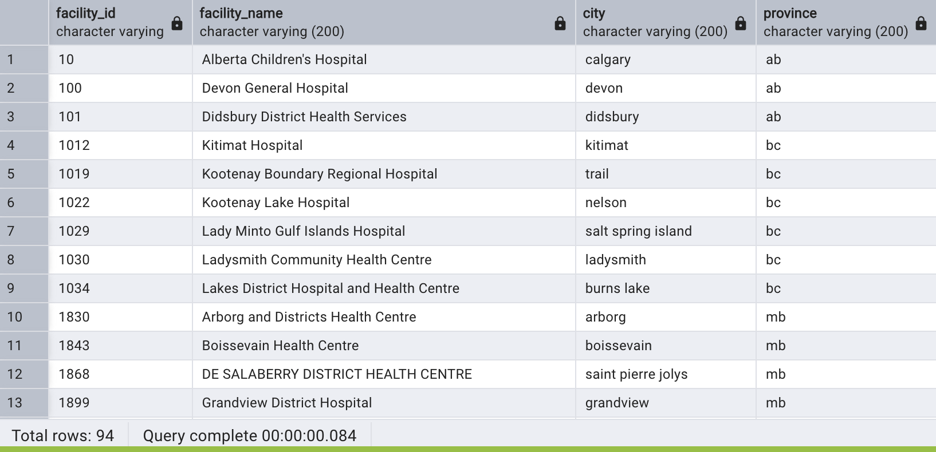
Insight
By pre-joining linked rows, this view makes it easier to obtain key facility data (ID, name, city, and province). It facilitates rapid reporting, filtering, and analysis of the facilities' distribution throughout provinces and cities.

- Conclusion section

Using the ODHF dataset, this project offered insightful information about the accessibility and distribution of healthcare facilities across Canada. We analysed healthcare density, located underserved areas, and highlighted important healthcare hubs by creating a relational database and using complex SQL operations including joins, subqueries, and CASE statements. The development of reusable views made reporting and data analysis easier.

